February 10, 2015

City of Bentonville
117 W. Central Ave
Bentonville, AR 72712
Attn: Mayor Bob McCaslin and Bentonville City Council

Dear Mayor McCaslin and Bentonville City Council:

This letter is written to express my concern regarding the proposed action of investing public funds in rebuilding the Lake Bella Vista dam on Little Sugar Creek in Bella Vista, Arkansas. I base my concern on the current observed leakage through the existing dam, and the karst geology of the St. Joe Limestone which underlies the dam and much of the Bella Vista area. The dam site lies very close to a major basement fault, which is known to allow interaction between surface water and groundwater, especially in areas where limestone lies near the land surface and is subject to dissolution and karstification.
As a matter of introduction, my name is John Van Brahana. I have worked for 28-years with the U.S. Geological Survey (in the midcontinent region of the United States as an Hydrologist, and 23-years as a Professor of Geosciences at the University of Arkansas, Fayetteville. I retired from the University in May 2013, and from the USGS in September of 1999. I earned my Ph.D. in Hydrogeology at the University of Missouri, Columbia, in 1973. Since 1990, I have worked closely with members of the state and federal agencies striving to help address vulnerability of karst lands and water-quality issues in the karst terrane of the southern Ozarks. I have supervised numerous student theses and research projects dealing with karst science, and I have conducted and published nationally and internationally on topics relevant to karst. Dr. Tom Sauer (U.S. Department of Agriculture, Agricultural Research Service) and I developed the Savoy Experimental Watershed (SEW) on Division of Agriculture property contiguous to the Illinois River in northwest Arkansas in the mid-1990s, and since that time this facility has been the center of an intensive infrastructure of karst water-related studies.

The existence of karst hydrogeology along Little Sugar, Spanker, and McKisic Creeks is well documented, and is based on the existence of: caves; sinkholes; enlarged, clay-filled fractures; losing reaches of streams; springs; and dye traces from Civil War Cave in Bentonville to Little Sugar Creek in Bella Vista (Aley, 2011). Dams require special engineering study in karst areas, for as they store water behind the structure, the weight of this water has been known to create leaks that can ultimately blow out the clay plugs that fill underlying fractures, causing dam leakage and failure. These are known from similar geologic settings in the Ozarks, and special care must be taken to assess an area before such construction takes place. I am greatly concerned that an adequate environmental assessment of the karst contiguous and underlying Lake Bella Vista has not been undertaken, and I would like to share my concerns prior to the city spending a large amount of taxpayer’s money. If you have questions, please feel free to contact me at brahana@uark.edu .
Respectfully submitted,
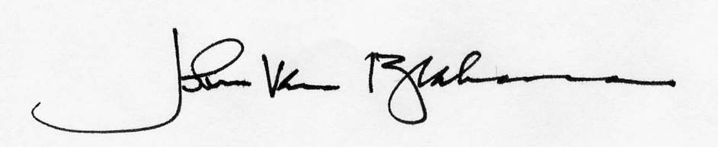
John Van Brahana, Professor Emeritus
Department of Geosciences
University of Arkansas

