Dagger Ultrafuge:
Length 7’7”
50 gal
The boat that stood the freestyle world on end. Aggressive sharp-edged hull design with slice and dice ends. Designed to give smaller paddlers a big advantage. Lets you shred the smallest of river features. Becomes a plastic squirt boat for those over the weight range willing to shoehorn in.

Boat is very similar to this color and has had a Jackson backband installed for improved comfort of snugging in your fit.
Liquid Logic Skip:

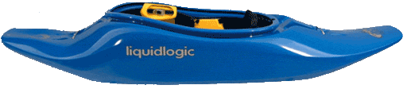
Length approximately 6’
Volume 41 gal
Small & slicey great boat for learning to cartwheel or building endurance for multiple ends.

